*Traffic Rush Developer Documentation*

**Game design**

**Overview:**

Traffic Rush is a singleplayer endless runner, where players can fulfill their dreams of driving like there is no tomorrow. Players control a car speeding on the wrong side of the road on a 3-lane highway.

**Visuals:**

2D top-down view

**Menu:**

In the main menu, the player has the ability to choose their desired car. Each car changes the gameplay with it’s own specs (Agility, Sturdiness etc.).

**Gameplay:**

Cars are randomly spawned in every lane, each with different speed. The player’s speed increases as the game progresses. Score is represented by the travelled distance.   
Depending on the choosen car, the player has a certain amount of lives. In this context life is equivalent to how many crashes a car can take. After every crash, the players car falls back a bit. The game ends when the player reaches the bottom of the playable area.   
After every ~1000 meters travelled, incoming traffic clears up and a mini-boss appears (some special vehicle). This is the only type of enemy the players will encounter. To defeat these enemies, players need to manouver away from incoming attacks. If this sequence is completed, the game continues.

**Controls:**

* Lane switching – *Left arrow, Right arrow*
* *Shooting - Spacebar*

**Planning**

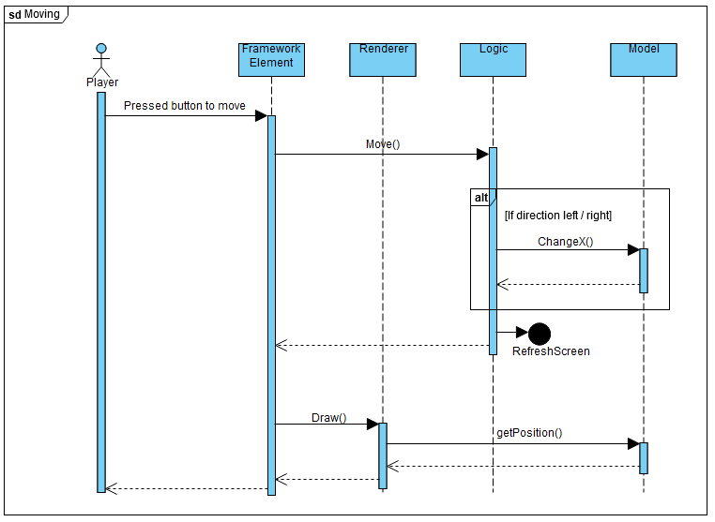

Sequence diagram of core gameplay mechanics

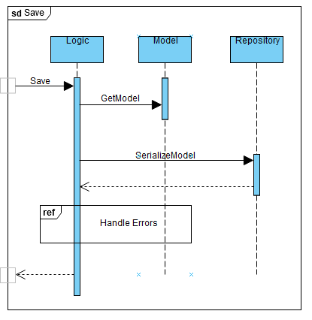

Sequence diagram of saving mechanics

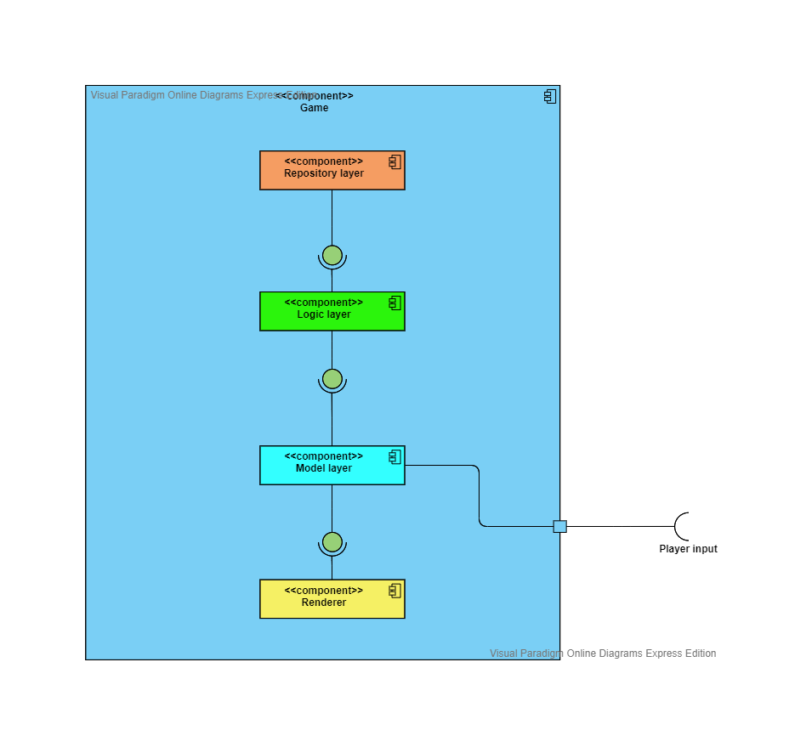

Schematic diagram of components

**Concept art, wireframe plans**

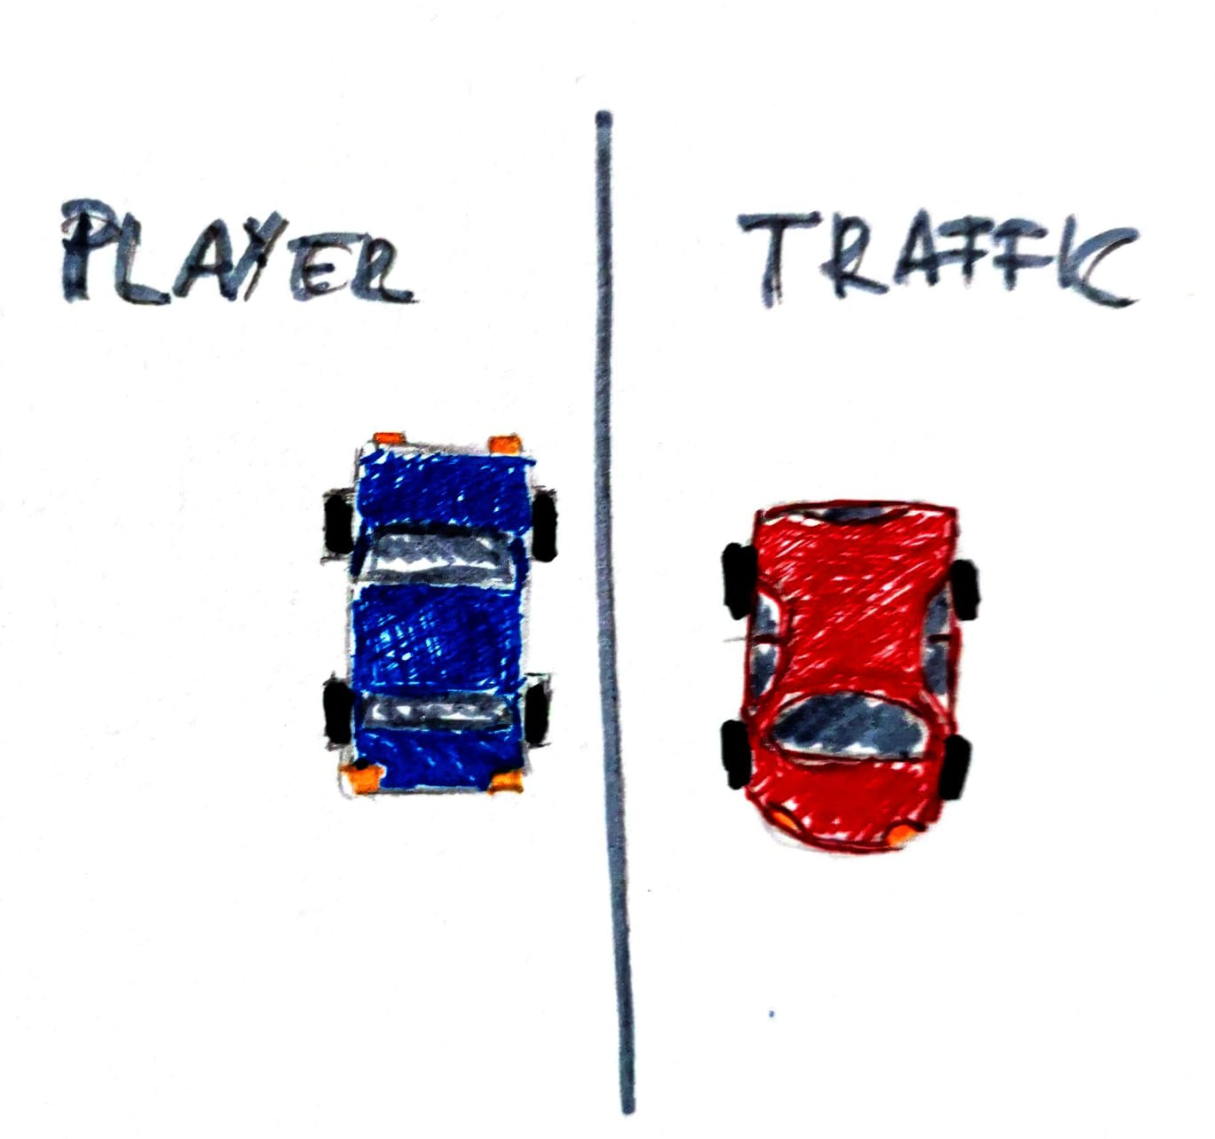

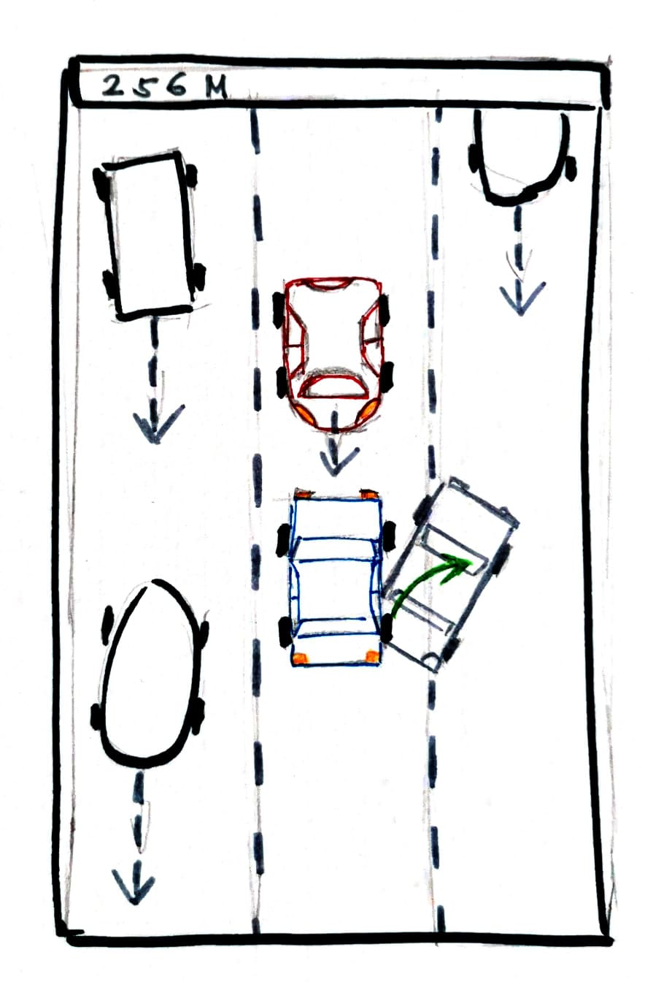

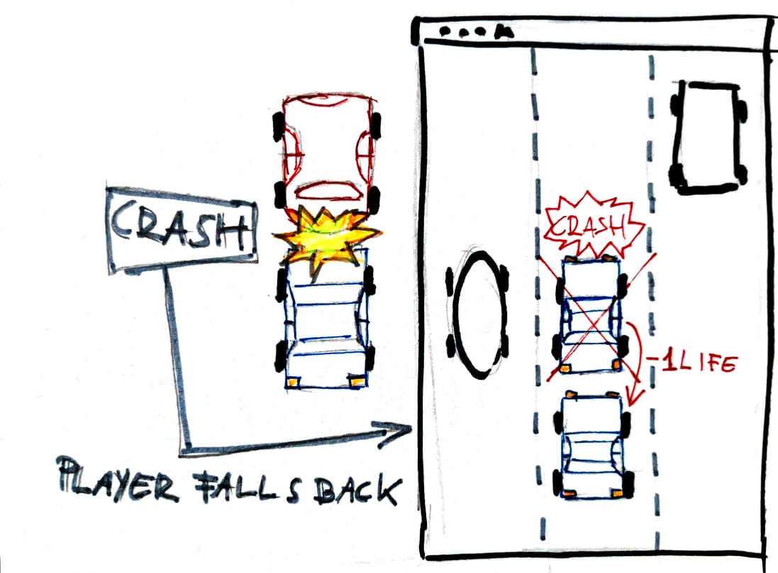

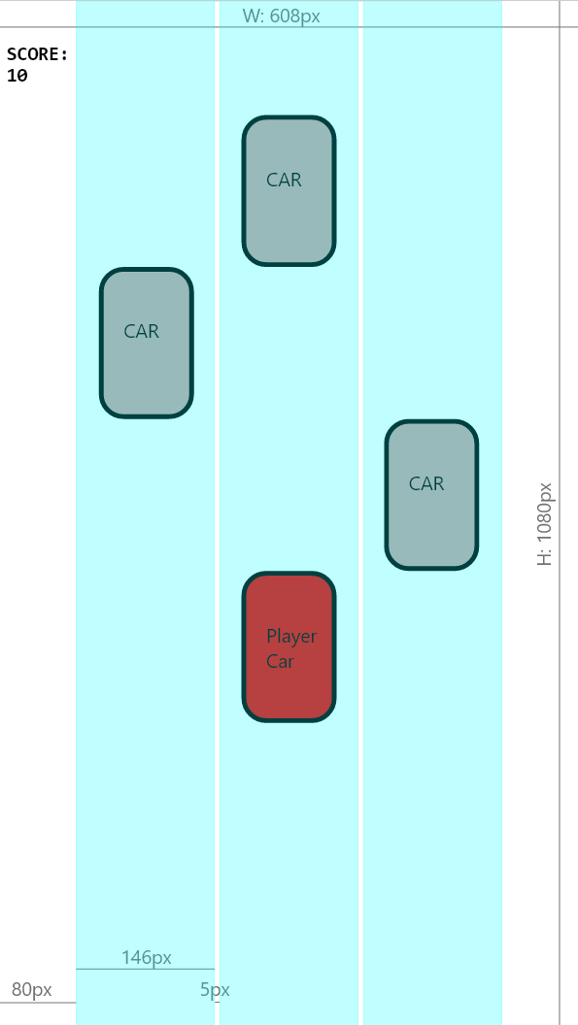

**Class hierarchy**

